MSBX 5145: Advanced Data Analytics Group Project

Unlocking the Secrets of Amazon's Bestsellers: Insights and Strategies

Ariadnee Ziady, Christina Kuleshevich, Gabriela Garcia Gonzalez, Rebecca Yoder, Vishwajit Mohan Kumar
10/08/2025

Introduction:
Ecommerce has become a dominant method of consumption in 2025 and continues to grow. The United States International Trade Administration has predicted that global business-to-consumer (B2C) ecommerce revenue will reach USD $5.5 trillion by 2027, growing at a steady compound annual growth rate (CAGR) of 14.4% (Bledsoe, 2024). Of all ecommerce companies, Amazon has the largest market capacity worldwide (Watty, 2025) (Appendix 1). Thus, with Amazon’s impressive market capacity and the world-wide growth potential of ecommerce as a whole, it is important for data scientists to be able to analyze product information in order to make sales predictions that allow for informed decisions by key stakeholders. The present paper aims to describe the process of cleansing and analyzing a set of Amazon product sales data in R in order to determine which products will be Best Sellers and develop predictions for volume of products sold.

About The Data:
The dataset used in this exploration comes from kaggle.com and includes over 40,000 data points for electronics products. The dataset includes information about the products such as product name, ratings, reviews, pricing, discounts, best seller badge information, sponsor information, and more. An early observation about this data is the class imbalance of the dataset concerning the Best Seller information, with 5.9% of the data points being a Best Seller. Noting this is a difficulty, the present exploration aims to answer the following questions:
- Can we create a model to predict which products will be labeled as a Best Seller with high sensitivity?
- Can we create a model that predicts the volume of a product that has been purchased?
The first question, if answered, can help Amazon choose which products to push and apply certain deals to in order to increase sales and traffic. The second question can help Amazon and sellers on Amazon increase shop efficiency by informing sellers on which products to keep stocked, quantity of supplier reorders and more.
An important note for this investigation is that the accuracy rates of the models were not considered due to the disproportionately high number of non-Best Sellers. Since accuracy could be misleading, sensitivity was used as the metric for success, with the goal of maximizing True Positives.

Data Cleansing and Visualization:
The initial stage of the analysis focused on ensuring the dataset was accurate, consistent, and ready for modeling. In the Amazon dataset several quality issues were identified, including typographical errors, inconsistent pricing fields, missing values, and duplicate entries. We removed duplicate rows (32,610), and standardized text-based columns. Columns containing URLs, images, and other data irrelevant to the current investigation were removed.
To improve data quality, missing values in a key numeric column, Units Sold, were imputed with median values within each product category. Additional binary flags were created to capture key business features such as: best_seller, coupon, discount, and sponsored. For pricing data, multiple fields were combined and corrected to ensure internal consistency.
Finally, several new features were engineered to enrich the dataset, including a normalized rating_scale and discount_percentage to quantify each product’s markdown level. Log transformations were applied to skewed numeric columns. After cleaning, the dataset contains 8690 observations of 24 variables.
The graphs presented in our work demonstrate skewness, visual comparisons of features between the two classes, and the difference in quantity of observations of Best Sellers vs non-Best Sellers. Of note, there is a right skew between number of reviews and number of products (Appendix 2). From this, we can expect that there will be fewer reviews on items that are in the higher price range. Another important initial evaluation was the review comparison between Best Seller and non-Best Seller products. As seen in the boxplots (Appendix 3) there is no clear variable that appears to be a predictor of a product being a best seller.

Modeling The Data:
To model the data and address the first business question of predicting Best Sellers with high sensitivity, we created three different models. The models used included: binomial logistic regression, a classification tree, and a classification tree model with bagging.
The first iteration of the logistic regression included all variables to determine which had the highest influence in predicting best sellers. Those variables were determined to be ratings, log transformation of reviews, sponsored (or not), log transformation of units sold, the percentage of discount applied, and the product category. Predictions and a confusion matrix were created based on this model at different thresholds and will be discussed later in this paper. The second model created was a classification tree made of the same variables as the logistic regression, except for product category, and sensitivity was calculated for this model. The final model created in this part of the exploration was a classification tree with bagging. In this model, the number of bags was arbitrarily chosen to be 100 in order to work with as many bags as possible without sacrificing computing ability in R. The same variables as the classification tree were used. Sensitivity was calculated and a confusion matrix created for this model and its predictions, and all three models were compared. The comparison of these models and reasoning for the chosen best model will be discussed in the Predictions section of this paper.
To answer the second business question, we created a linear regression model. The model was created by initially incorporating all variables and then using backwards elimination to select the most impactful variables. The final variables included in this model were: rating, log transformation of number of reviews, log transformation of price, discount percentage, sponsored (or not), product category, and best seller.
Predictions:
Our project focuses on three different models to find answers to our first business problem. After cleaning the data, the full dataset was split 70/30 into two groups: training and testing. The split datasets mirrored the full dataset in terms of the Best Seller class imbalance, with the training and testing dataset each consisting of 5.9% and 5.8% Best Seller products, respectively. The predictive models were created using the training dataset, and predictions were made with the testing dataset. Below we discuss the results of the predictions with each model.
- Logistic Regression - To judge the quality of the model, we focused on sensitivity; then, we determined the log odds of the change of one unit in each feature. Multiple predictions were made with different thresholds (0.5, 0.3, and 0.2). We evaluated the predictions of each threshold and included results on the threshold that was most successful (0.2). To clarify, using this threshold means if the model predicted a product to be a best seller with 20% probability, we would classify them as a best seller. We noted low sensitivity levels (16.7%) signaling that the model’s predictions of True Positives were not confident (Appendix 4). However, to determine and assign a value to the impact of each predictor variable, we evaluated the log odds from the logistic model (Appendix 5) and found the following:
  - Rating - Positive ratings have an impact on the model’s prediction of Best Sellers. A one point increase in positive ratings (e.g. 4.0 vs 5.0) has an odds increase of 169%, or roughly 2.69.
  - Reviews - For each one additional unit of log number of reviews, the odds of becoming a Best Seller increase by approximately 11.2%.
  - Sponsorship Label - This is the most substantial factor in shaping the outcome of becoming a Best Seller. Product sponsorship increases the odds of being a Best Seller by 305% or about 4x, meaning that this is a valuable investment for a merchant selling their product.
  - Units Sold - For each additional log unit sold of a product, the odds of it becoming a Best Seller increase by 38.4%.
  - Discount Percentage - For each roughly one percentage point increase in discount of price, odds of becoming a Best Seller increase by about 1%. With this, a product discounted by 10% also has a 10% increased odds of becoming a Best Seller.
- Classification Tree - The simple classification tree yielded accuracy of 94.4% and a sensitivity of only 7%. According to this model the most important predictor was the units sold and it begs to question whether a product is a best seller because it sells large quantities or the other way around. With these results this model was discarded as not a good fit (Appendix 6-7).
- Classification Tree with Bagging - After creating predictions with this model, we determined this model to be the best fit because of sensitivity levels of 23.3% with True Positives detection of 35/115. This model showed less variability when compared to other models due to the sample replacement. A confusion matrix was created to visualize the performance of the model.
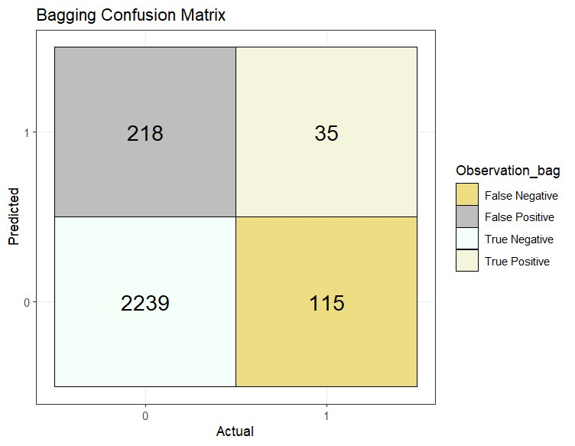
Figure 1: Confusion Matrix for Tree Model with Bagging
To improve sensitivity, we modified the threshold levels to 0.2 to maximize True Positives. This model netted a sensitivity of 23.3%. Considering the given metrics of the Classification Bagging Tree Model, we used this model to predict best sellers.
Performance Summary of Best Seller Regression Models
To compare the above models, we input the results presented in Table 1. For our dataset the Classification Tree Model with Bagging is the best model for identifying best sellers because it has the highest sensitivity.
Model​ | Accuracy​ | Sensitivity​ | Key Notes​
Logistic Regression​ | 92.9%​ | 16.7%​ | Sensitivity Gain​
Tree​ | 94.4%​ | 7%​ | Overfits​
Bagging​ | 87.2%​ | 23.3%​ | Sensitivity Gain
Table 1: Binary Classification Model Evaluation
Our second question was addressed with our final model using linear regression. This was designed to predict the log transformation of Units Sold as the outcome variables with the predictor variables being ratings, log reviews, log price, discount percentage, sponsorship, product category, and best seller badge. Our regression model determined the following variables to be associated with high sales volume:
  - Gaming Products, Speakers, and Power & Batteries - With significance values of 0.000129, 0.000177, and 2.92e-8, respectively, products in these categories are of significance to the predictive model. The negative coefficients of Speakers and Gaming indicates that products with these characteristics are associated with lower log units sold. Power & Batteries is associated with a higher outcome of log units sold.
  - Log Reviews - Highest significance levels, a major driving factor of model predictions.
  - Log Price - High level of significance in the model with a negative coefficient, indicating higher prices decrease the model’s predictions of log units sold.
  - Sponsored Label - Second highest significance levels, sponsorship heavily influences model predictions of sales.
  - Ratings - Higher ratings correlated with higher sales volume.
  - Discount Percentage - Large discounts correlated with higher sales volume.
  - Best Seller - A best seller badge was correlated with a higher prediction of sales and was a significant predictor of the quantity of log units sold.
However, this model was determined to not be a good fit since it has a low Adjusted R-squared value of 0.41 and the residuals plot contains diagonal striping artifacts. After further investigation, it was determined that this model’s poor performance may be related to the common frequency counts of the Units Sold feature, an issue within the data that was not discovered in initial investigations (Appendix 8 - 11). Overall, the residual standard error was 0.9869 on 6059 degrees of freedom; the adjusted R-squared was 0.41; the F-statistic was 184.7 on 23 and 6059 DF; the p-value was < 0.00000000000000022.

Implications and Suggestions:
The findings from this analysis provide practical insights for Amazon sellers and stakeholders seeking to optimize product performance and maximize best-seller potential.
- Strategic Investment in Sponsorship: Product sponsorship increases Best Seller odds by roughly 4x, making it the single largest predictor in our model. Merchants should prioritize marketing budgets toward Amazon's sponsored product programs.
- Managing Customer Perception: Each 1-point rating significantly increases the likelihood of becoming a Best Seller, suggesting merchants should focus on quality control and customer satisfaction initiatives. Additionally, doubling the reviews increases odds by 7.60%, indicating that encouraging customer reviews early through follow-up communications can meaningfully impact success, though this strategy has diminishing returns at higher review counts.
- Category-Specific Sales Forecasting: Power & Batteries showed significantly higher predicted sales volumes. Sellers and inventory management teams can use these predictions to optimize stock levels.
- Pricing Strategy: Each 1% price discount increases Best Seller odds by approximately 1%, allowing sellers to calculate expected returns from promotional pricing against margin considerations.
Model Limitations:
With the poor performance of the linear model, appropriate changes can be made to improve the fit of the model. Due to the distribution of the Units Sold data points skewing the model, a proposed plan to improve this would be to use a multinomial logistic (MNL) regression model instead and group the units sold, reviews, and ratings variables into bins. This is a promising solution because the bins for units sold and review counts could be organized based on a logistic scale (ex: 1-10, 10-100, 100-1k, 1k-10k, 10k-100k) which would present more normalized data due to the high range and relatively low unique values in each of the previously mentioned variables. While the MNL regression would be outside of the scope of this project, it would provide an interesting follow up study.
The logistic model struggled to properly predict True Positives even with the adjustments made to threshold and predictor variables. The severe class imbalance limits modeling predictive power, with our best-performing model achieving only 23.3% sensitivity. Future work should explore oversampling techniques or other methods to improve sensitivity for practical business application.

Conclusion:
This study developed predictive models to categorize Amazon Best Sellers and predict product volume sold for an imbalanced dataset. The analysis reveals that ratings and sponsorship are the paramount driver of success. Other strategies like discounting products produce measurable but secondary effects. Future research should address our study's limitations and incorporate textual analysis of reviews and competitive dynamics to further enrich understanding of marketplace success.

References:
201. (n.d.). eCommerce Sales & Size Forecast. Retrieved October 4, 2025, from
https://www.trade.gov/ecommerce-sales-size-forecast
Amazon Products Sales Dataset 42K+ Items—2025. (n.d.). Retrieved October 4, 2025, from
https://www.kaggle.com/datasets/ikramshah512/amazon-products-sales-dataset-42k-items-2025
Top large cap e-commerce companies by market cap 2025. (n.d.). Statista. Retrieved October 4,
2025, from
https://www-statista-com.colorado.idm.oclc.org/statistics/245340/leading-large-cap-e-co
mmerce-companies-market-cap/

Appendix:

Appendix 1. Leading e-commerce companies worldwide (Watty, 2025)
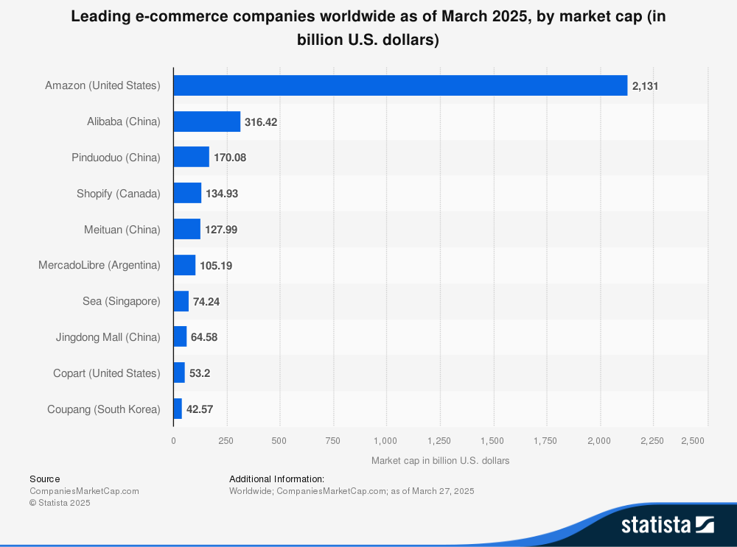

Appendix 2. Histograms of data before and after the log transformation
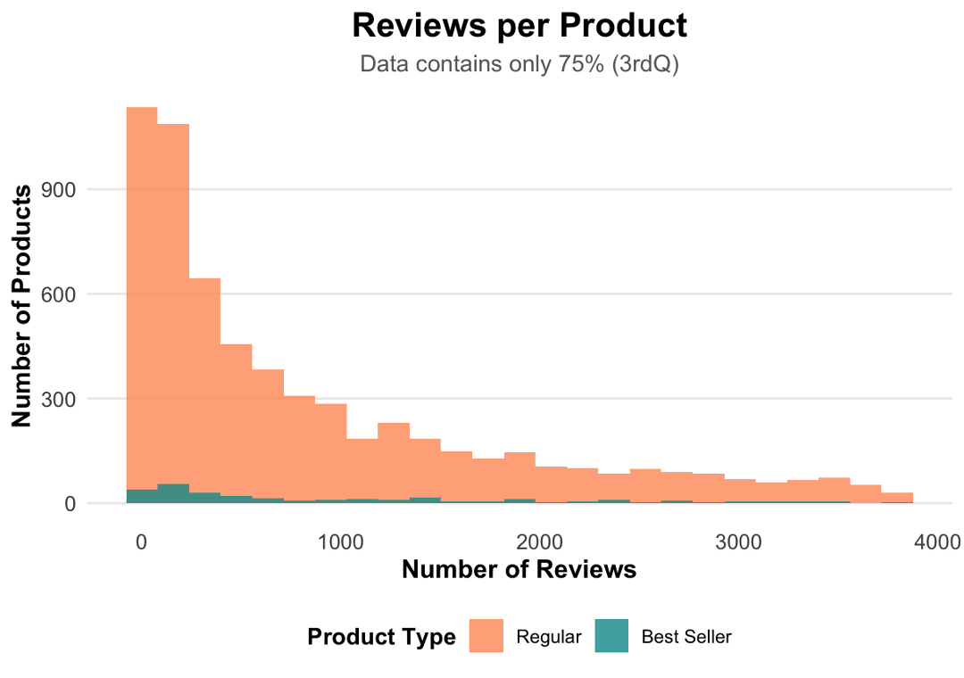
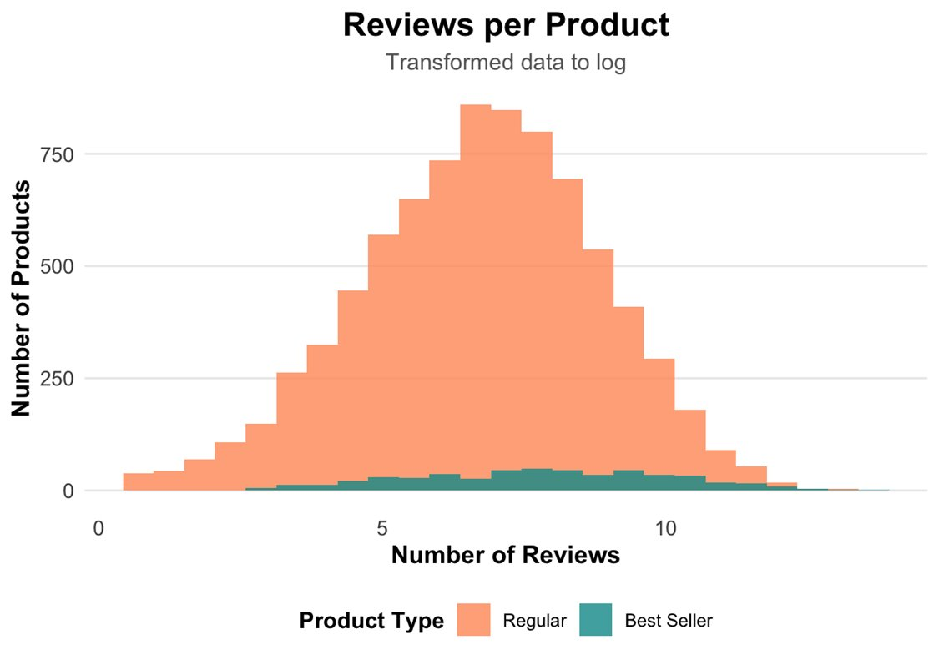

Appendix 3. Boxplot of best seller by number of units sold and number of reviews
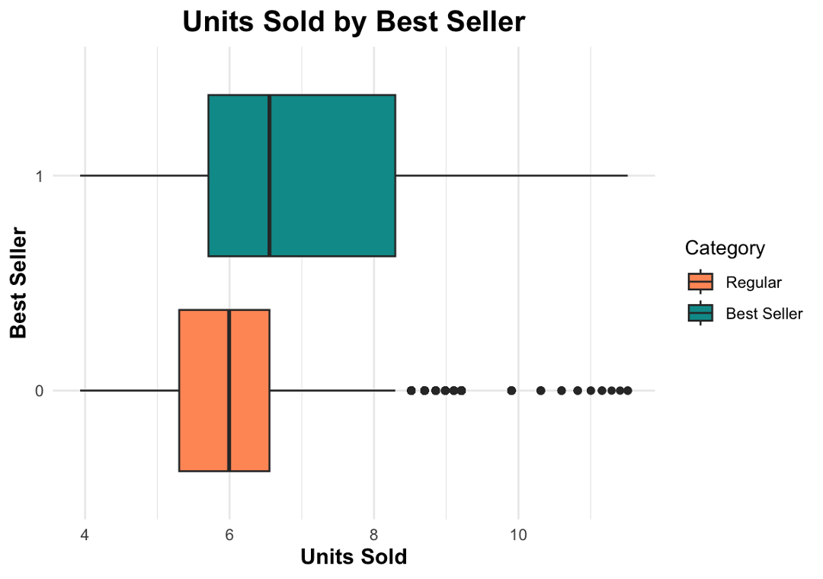
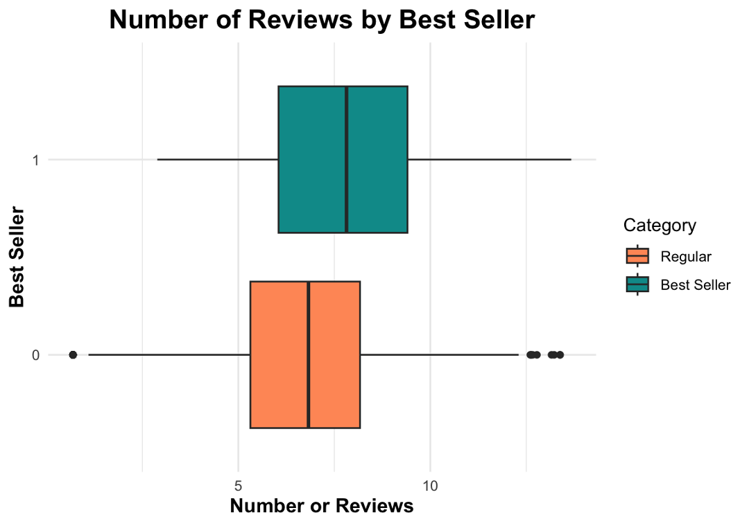

Appendix 4. Logistic Regression Model Confusion Matrix
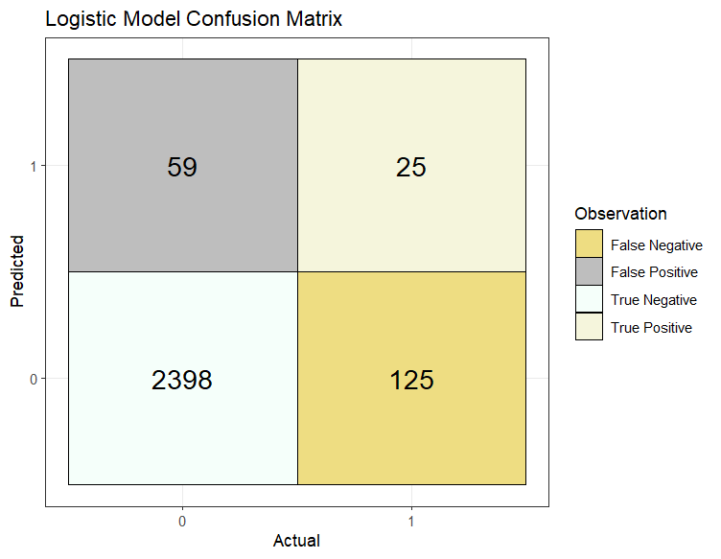

Appendix 5. Table of Log Odds from Logistic Regression
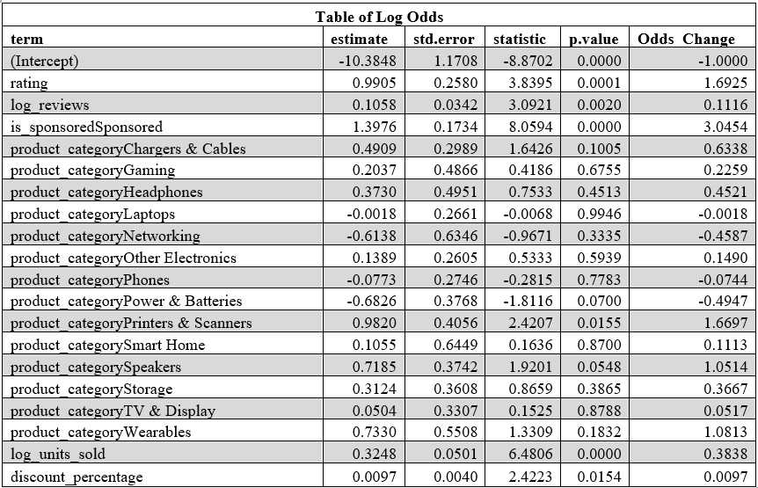

Appendix 6. Classification Tree
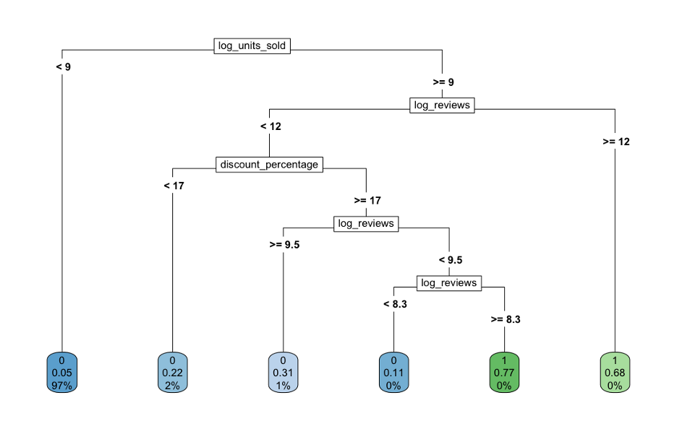

Appendix 7. Classification Tree Confusion Matrix
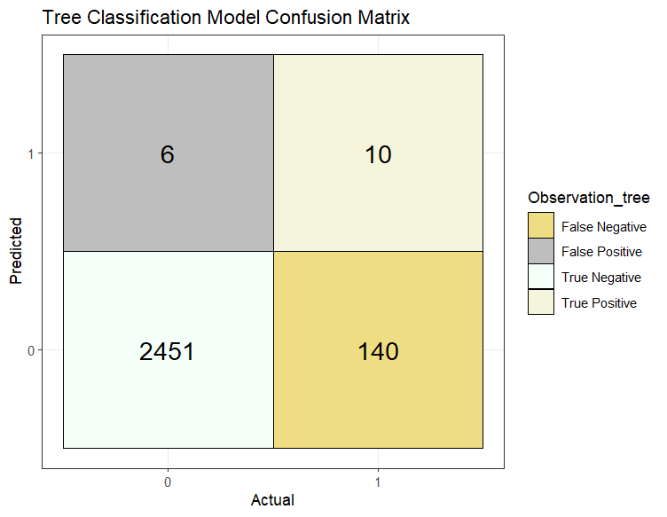

Appendix 8. Residual vs Fitted Values (colored by product category)
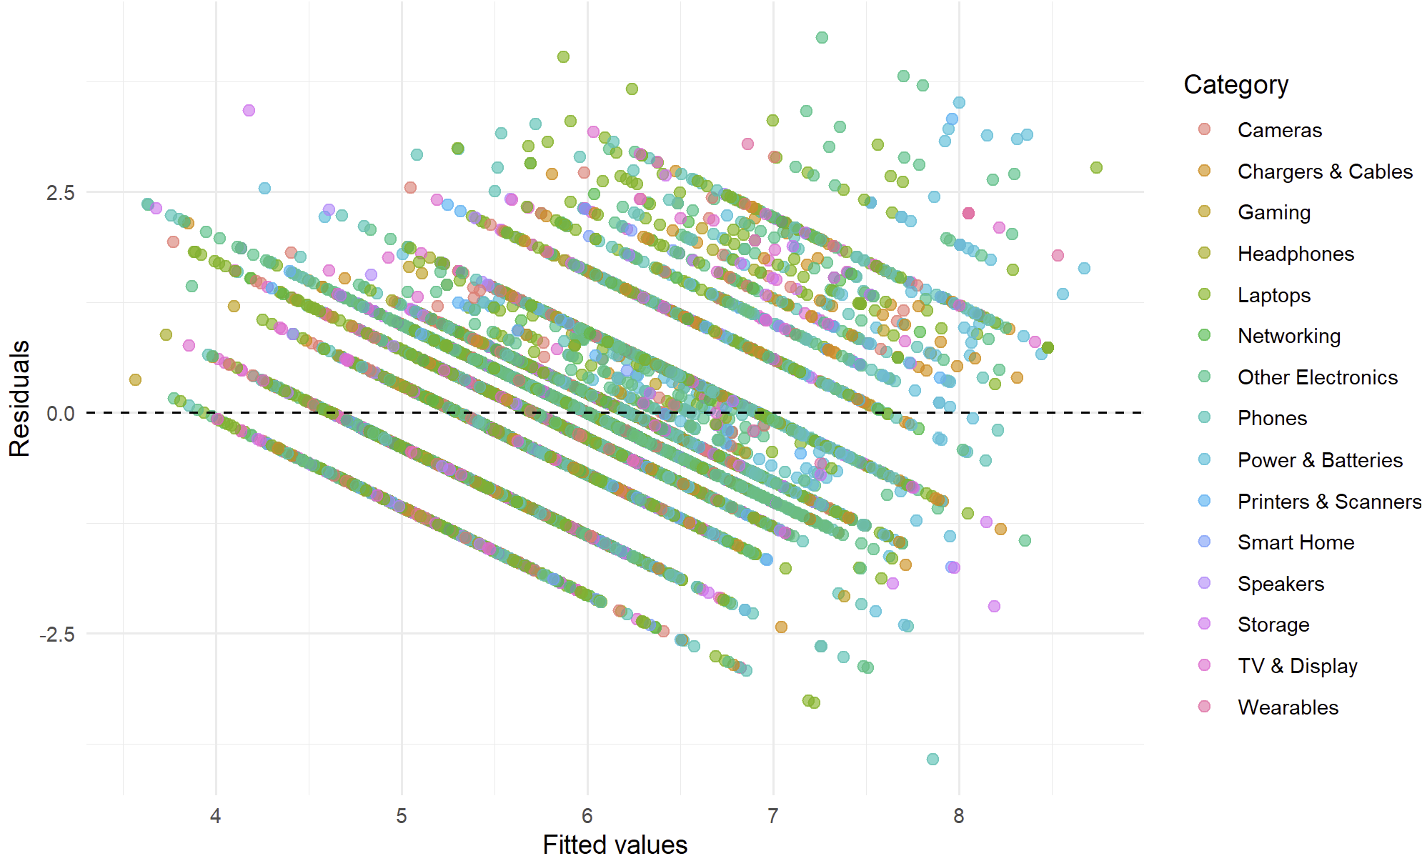

Appendix 9. Residual vs Fitted Values (colored by sponsored)
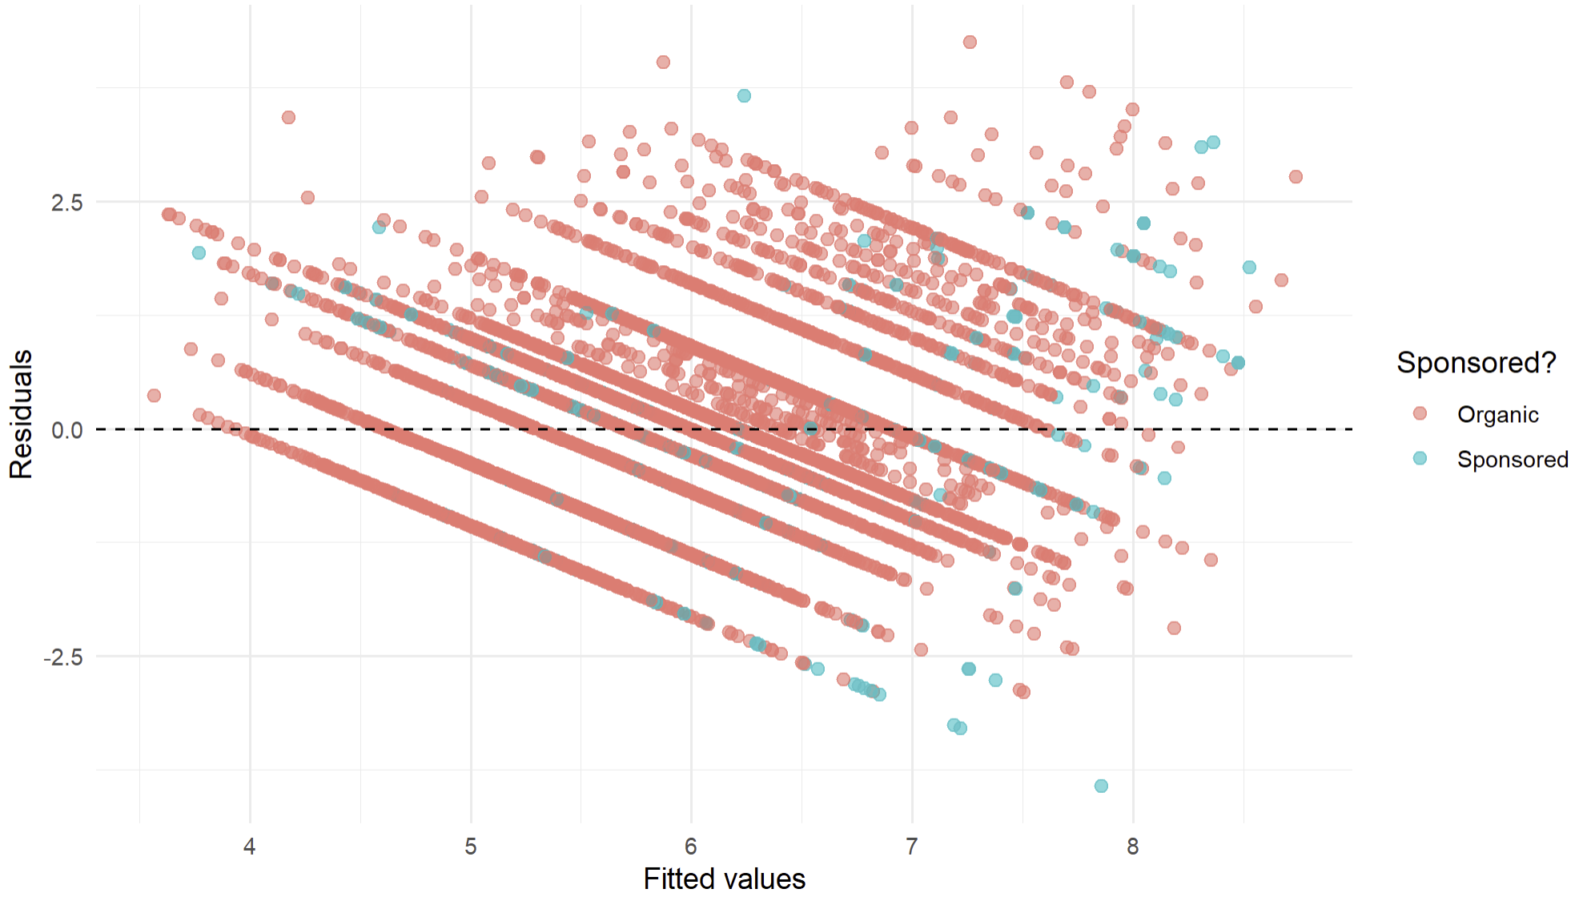

Appendix 10. Residual vs Fitted Values (by different product categories)
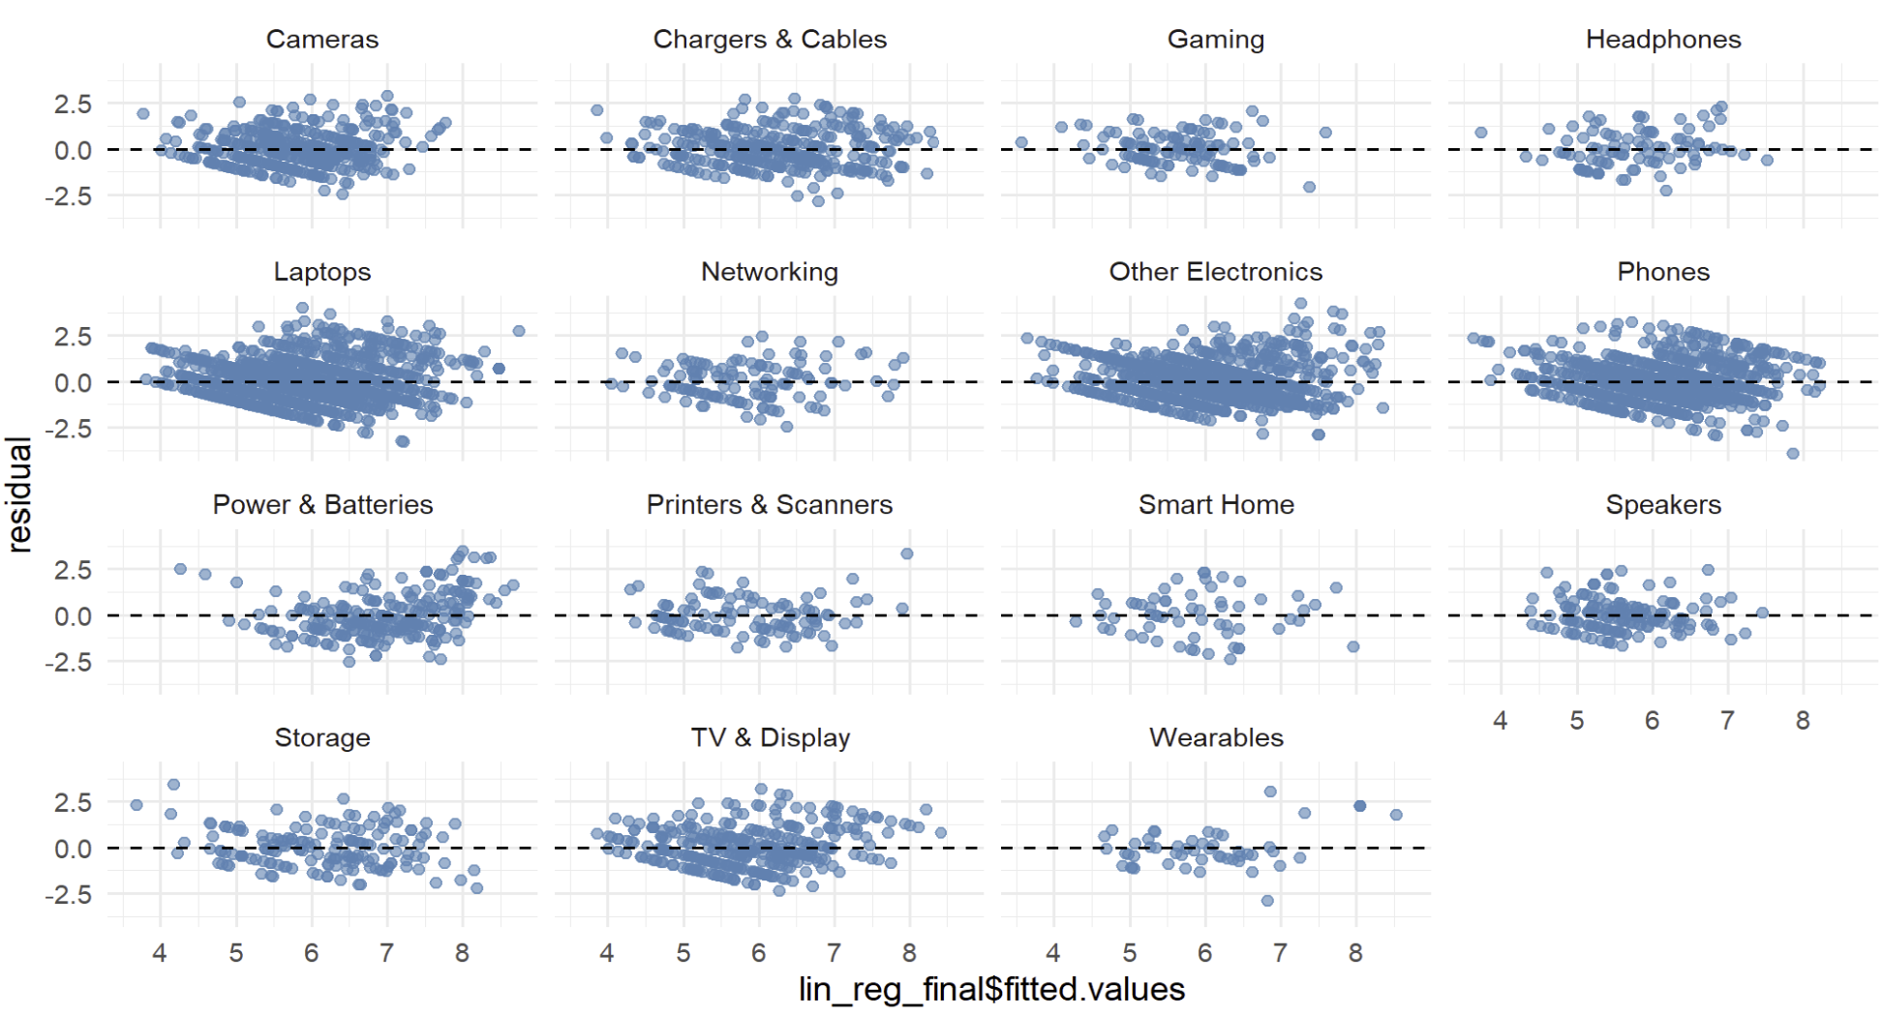

Appendix 11. Residual vs Fitted Values (by Frequency of Units Sold)

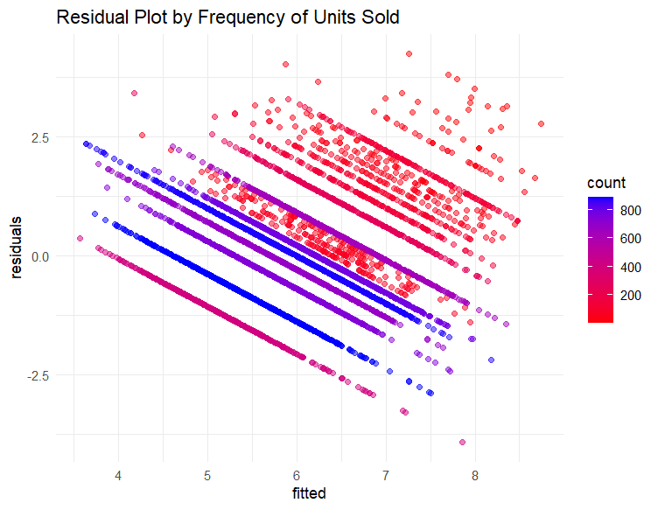

Appendix 12. Pie Chart of the top 5 product categories
The top 5 Category Pie chart provides a clear view that only the top 5 products have around 80% of the products sold. Here we noted that in some of the categories the range of products could be very large. (e.g. Laptop category will include the all the accessories that are related to laptops)
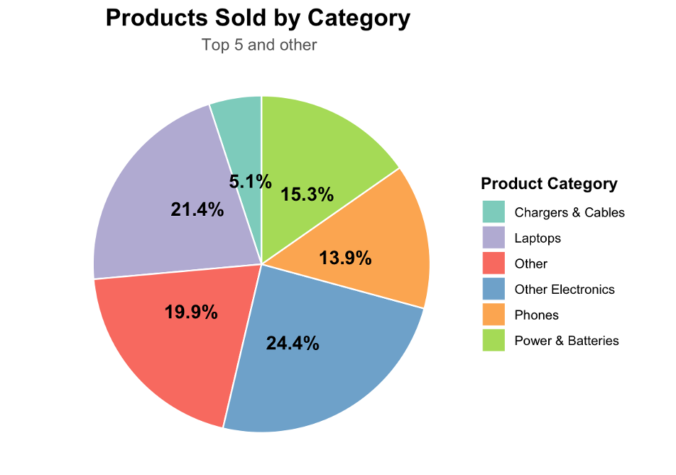

Appendix 13. Product Categories of Best sellers.
The best seller by product category data is a further detail shown of what categories have more best seller products in them. The other electronic category includes products that vary from batteries to calculators. As mentioned before these will have a larger turnover in purchase thus increasing their weight on best sellers overall total units.
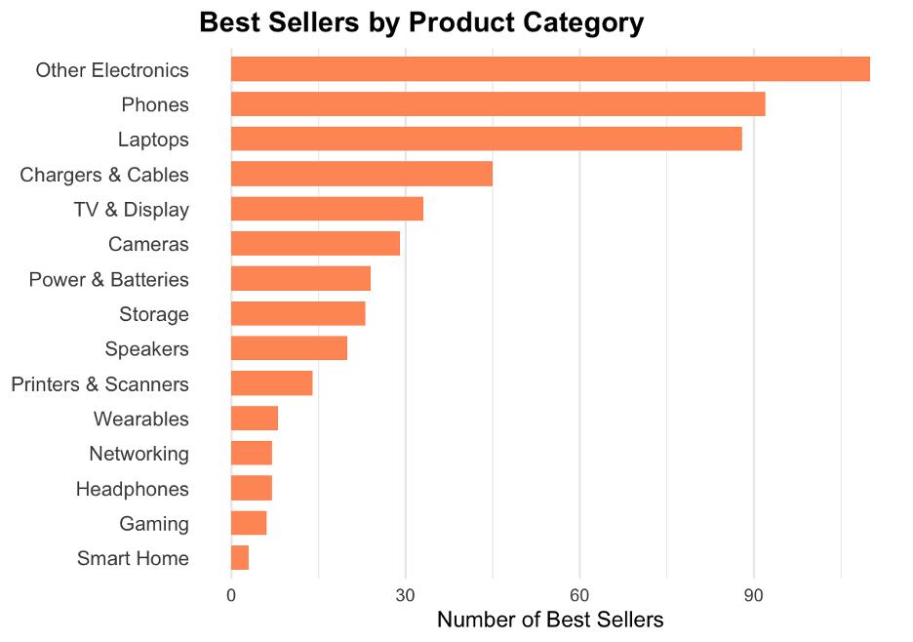

Appendix 14. Comparison of best sellers/regular vs Product rating in stars and Price Range
In continuation on the visualization of data the following graphs will show the comparison on the best seller and regular product by rating (stars) and the price range on the products.
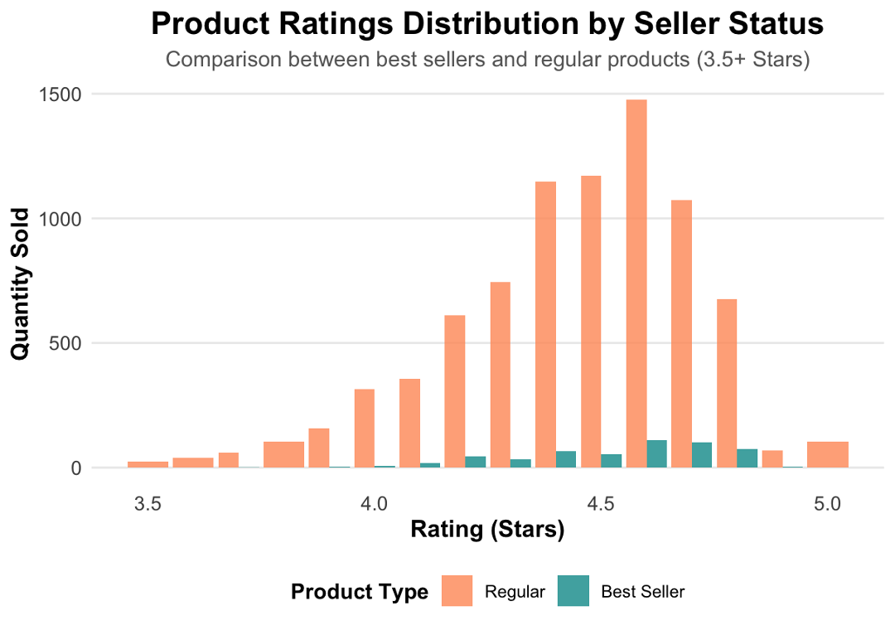

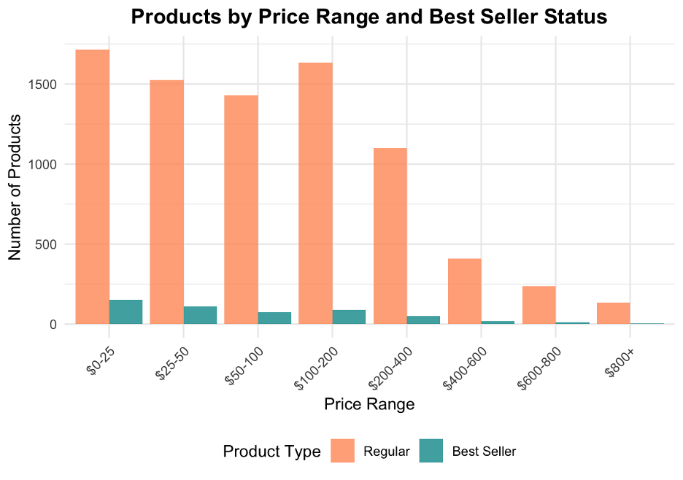

Appendix 15. Boxplots split by best sellers and regular products
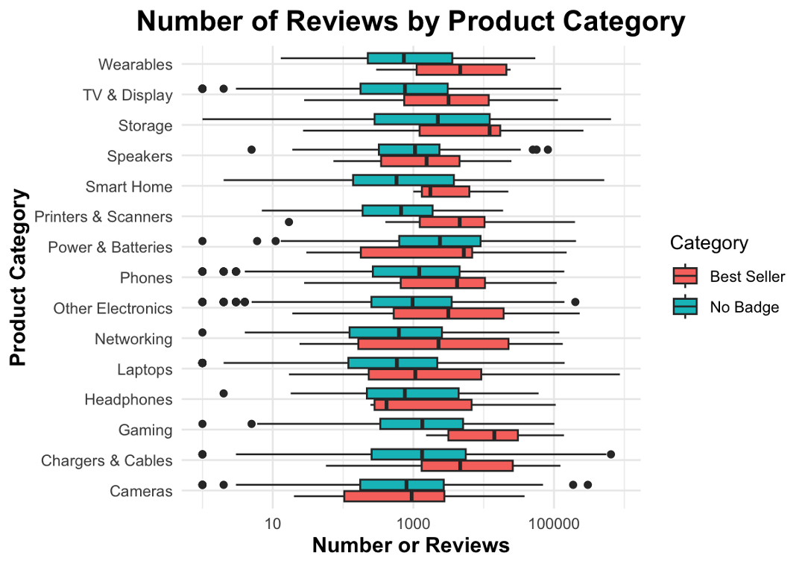
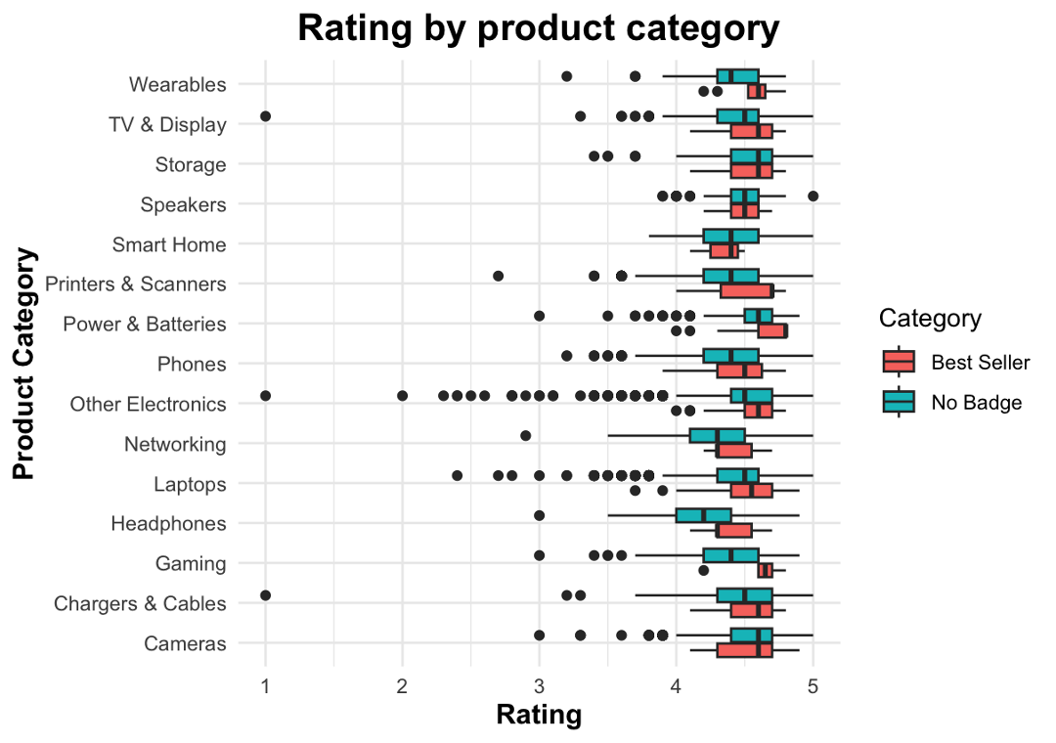

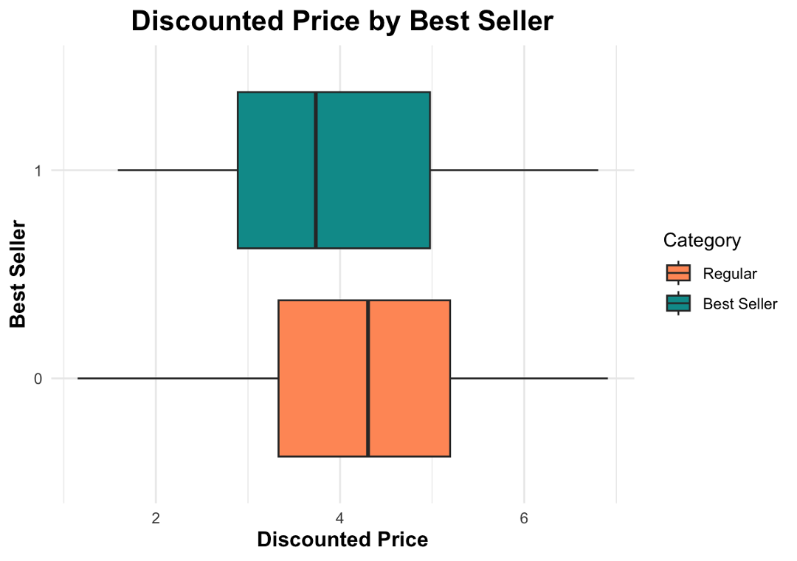

Appendix 16. Table of Summary Statistics for Notable Categories.
